**EcoSync** 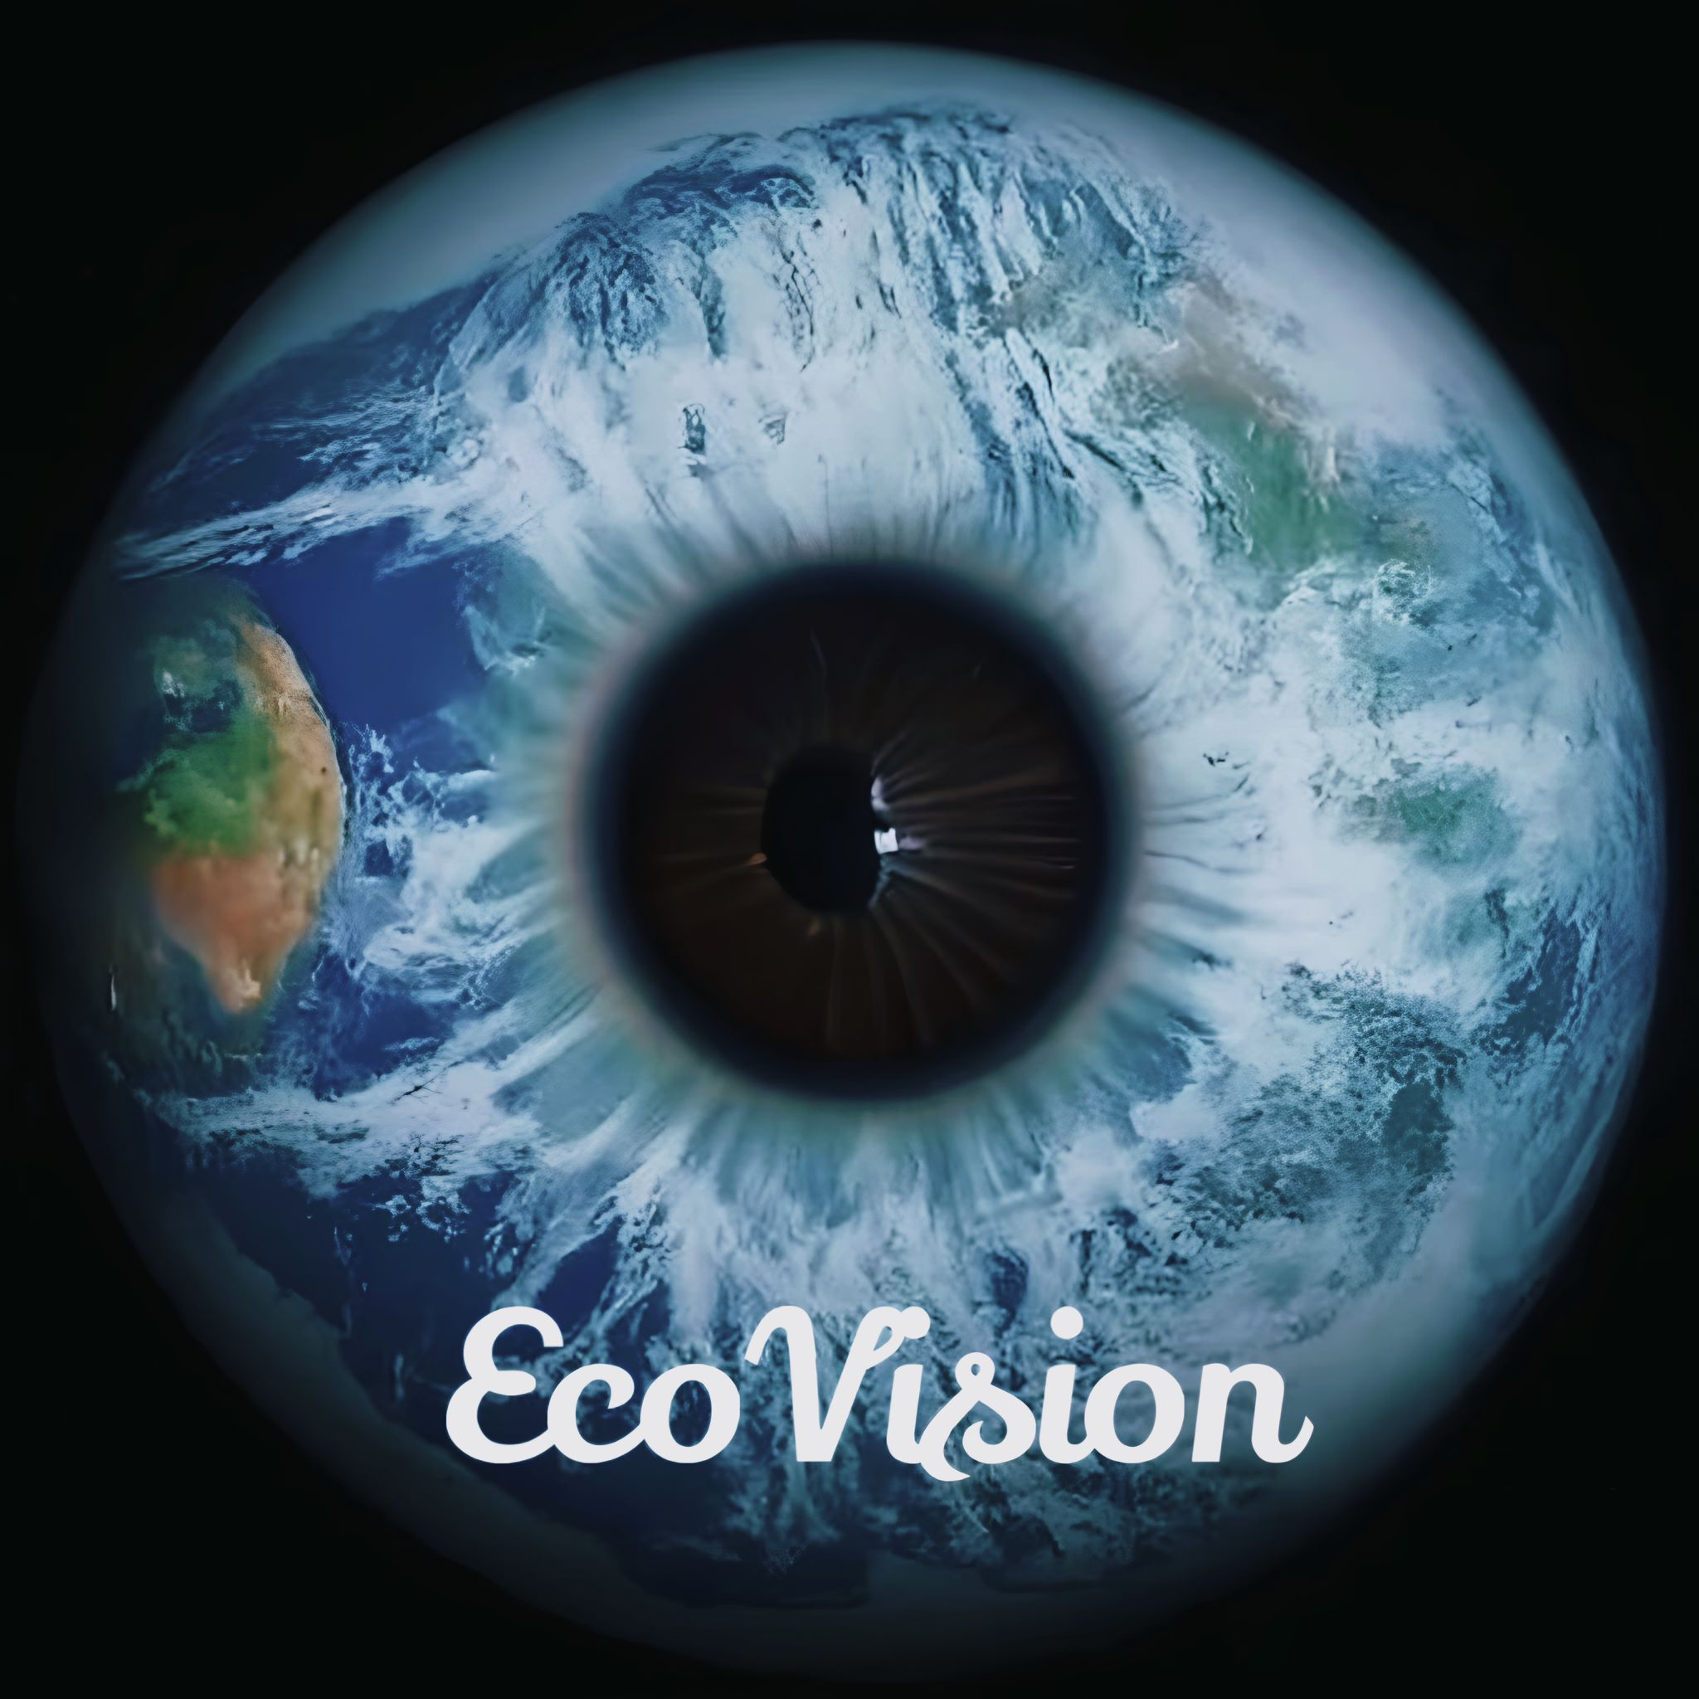  
 *Empowering Eco-Friendly Technology*

Praveen Kumar Madhava Rao  
VidyaSree Bharathwaj

Sasikala Palanisamy

Amani Gaddamedi

Kannika Kabilar

Adrianna Kocyba-Kostecka  
Prema Vivekanandan

Pedro Soares

**EcoBuddy 5.0: A Global Sustainability Symphony - Where Local Actions Compose Global Harmony**

Imagine a world where your daily choices, from your morning jog to your grocery list, contribute to a powerful movement for a healthier planet. A world where you connect with like-minded individuals across the globe, sharing tips, celebrating milestones, and composing a symphony of collective impact. That's the power of EcoBuddy 5.0, a groundbreaking initiative by XYZ Company, built by a geographically diverse team like yours, united by a passion for a sustainable future.

**The Challenge:** Traditional corporate sustainability efforts often feel isolated, focusing on individual companies without fostering a sense of community or global impact.

**Introducing EcoBuddy 5.0: Your Sustainability Conductor and Community Hub:**

* **Effortless Participation:** Seamlessly connect EcoBuddy 5.0 with your existing sustainability apps. With your consent, it anonymously collects data points to paint a personalized picture of your sustainability journey.
* **Your Daily Sustainability Scorecard:** EcoBuddy's AI assistant analyzes your data and provides **daily, weekly, and monthly personalized plans**. It also connects you with a local community leaderboard, where you can see the impact of your actions compared to your neighbors.
* **The "Eco-Buddy" Feature - Finding Your Local Sustainability Partner:** EcoBuddy connects you with a local colleague or neighbor also striving for sustainability. Share tips, celebrate local initiatives, and hold each other accountable, creating a **vibrant local community** that drives collective action.

**A Story of Local and Global Impact:**

Meet Sarah, a Marketing Manager at XYZ Company in Mumbai. Sarah's passionate about reducing her carbon footprint. She connects EcoBuddy with her smart home system and fitness tracker.

* **EcoBuddy anonymously analyzes her data.** It reveals Sarah's energy consumption is lower than the Mumbai average, but her commute generates higher emissions.
* **Personalized Insights and Local Action:** EcoBuddy suggests carpooling options and showcases local cycling paths, along with estimated CO2 savings. Sarah sees she's close to the top of the local leaderboard, motivating her to do more.
* **Enter Priya, Sarah's Eco-Buddy in Mumbai.** Priya shares tips on using public transport and suggests joining a local community clean-up event. They hold each other accountable and celebrate exceeding their individual CO2 reduction targets.

**Beyond Local Action - The Global Sustainability Symphony:**

* **The anonymized data Sarah and Priya contribute** helps XYZ Company understand broader sustainability trends and identify areas for improvement across its global operations. More importantly, it feeds into the anonymized data pool accessible through the secure "Bridge" concept.
* **Global Benchmarking and Collaboration:** This data, combined with anonymized data from other companies and local communities worldwide, allows for global comparisons and identification of best practices. This fosters collaboration towards shared sustainability goals, with local successes inspiring global action.

**XYZ Company - Leading the Global Sustainability Orchestra:**

By pioneering EcoBuddy 5.0, XYZ Company demonstrates its commitment to:

* **Empowering Local Communities:** We believe that local action is the foundation for global change. EcoBuddy fosters vibrant local communities that drive collective impact.
* **Fostering Global Collaboration:** We recognize that sustainability is a shared responsibility. EcoBuddy connects people across borders, enabling knowledge exchange and collaboration for a healthier planet.
* **Data-Driven Action:** We leverage anonymized data to inform strategic decisions and maximize our collective impact, both locally and globally.

**Join the EcoBuddy Symphony - Let's Harmonize for a Sustainable Future!**

XYZ Company to utilize the **anonymized data** from EcoBuddy 5.0 to **distinguish itself from other companies** in terms of **overall sustainability efforts**:

**1. Benchmarking and Progress Tracking:**

* XYZ Company can compare its **anonymized company-wide data** with industry benchmarks derived from **aggregated data across all participating companies**. This allows it to **track its progress** over time and identify areas for improvement compared to the industry average.

**2. Demonstrating Leadership Through Transparency:**

* XYZ Company can **publicly share its anonymized sustainability data** and **best practices** derived from EcoBuddy 5.0 insights. This showcases its **commitment to transparency** and **leadership** within the sustainability movement, even without directly comparing individual contributions.

**3. Highlighting User Engagement:**

* XYZ Company can showcase the **high user engagement** with EcoBuddy 5.0 within its organization. This demonstrates **employee buy-in** and **commitment** to sustainability efforts, which can be seen as a differentiating factor compared to other companies.

In conclusion, while individual contributions won't be measured publicly or used for comparison, EcoBuddy 5.0 empowers XYZ Company to distinguish itself by:

* **Demonstrating leadership through transparency and collective action.**
* **Benchmarking its progress against industry trends.**
* **Highlighting employee engagement and commitment to sustainability.**

**EcoBuddy 5.0: A Global Sustainability Symphony (Storytelling Video)**

**Scene 1: The Challenge (0:00 - 0:30)**

* Open with a montage of individuals across the globe engaging in various activities - commuting, grocery shopping, using energy at home.
* Narrator (soothing, optimistic voice): "We all want to make a difference, but individual actions can feel insignificant. Traditional sustainability efforts often feel isolated, progress is slow, and impact seems small."
* Text overlay: "The Challenge: Isolated Efforts, Limited Impact"

**Scene 2: Introducing EcoBuddy 5.0 (0:30 - 1:00)**

* Showcase a diverse team (like yours!) collaborating on a computer screen, depicting the development of EcoBuddy.
* Narrator: "Introducing EcoBuddy 5.0, a groundbreaking initiative by XYZ Company. Built by a geographically diverse team like yours, united by a passion for a sustainable future."
* Show the EcoBuddy logo and app interface on the screen.
* Text overlay: "EcoBuddy 5.0: Your Sustainability Conductor"

**Scene 3: Your Daily Sustainability Journey (1:00 - 1:45)**

* Follow Sarah, a Marketing Manager in Mumbai, using the EcoBuddy app.
* Show her connecting the app with her fitness tracker and smart home system.
* Narrator: "EcoBuddy seamlessly connects with your existing sustainability apps, painting a personalized picture of your journey."
* Show EcoBuddy analyzing Sarah's data and providing personalized suggestions (e.g., carpooling, local public transport options).
* Text overlay: "Effortless Participation, Personalized Insights"

**Scene 4: The "Eco-Buddy" Feature (1:45 - 2:30)**

* Introduce Priya, Sarah's local Eco-Buddy in Mumbai.
* Show them interacting virtually, sharing tips, and celebrating achievements.
* Narrator: "EcoBuddy connects you with a local 'Eco-Buddy,' a colleague or neighbor sharing your sustainability goals."
* Highlight local community features - leaderboard, local clean-up event participation.
* Text overlay: "Empowering Local Communities, Collective Action"

**Scene 5: The Global Sustainability Symphony (2:30 - 3:00)**

* Show the anonymized data from Sarah, Priya, and others flowing through a secure "Bridge" concept.
* Transition to a global map with data points representing anonymized contributions from various locations.
* Narrator: "Anonymized data from individuals and communities contributes to the global 'Bridge,' fostering collaboration and collective impact."
* Showcase how anonymized data helps XYZ Company identify industry trends and best practices.
* Text overlay: "From Local Actions to Global Impact"

**Scene 6: Join the Movement (3:00 - 3:15)**

* Show diverse individuals from different countries using EcoBuddy and celebrating their achievements together.
* Narrator: "Join the EcoBuddy Symphony! Together, we can create a healthier planet, one sustainable action at a time."
* Call to action: Download the EcoBuddy app and join the movement.
* Text overlay: "EcoBuddy 5.0: Together, We Can Make a Difference"

**Music:** Uplifting and inspiring background music throughout the video.

**Visuals:** Use a combination of live-action footage, animation, and data visualizations to create an engaging and informative storytelling experience.

**EcoBuddy 5.0: A Global Sustainability Symphony (UX/Figma Design)**

**1. Onboarding Screens:**

* Welcome users and explain the concept of EcoBuddy 5.0, emphasizing its focus on collective action and global impact.
* Guide users through the easy connection process with existing sustainability apps.

**2. Home Screen:**

* Display a personalized sustainability score based on anonymized data and user actions.
* Showcase daily, weekly, and monthly personalized plans with actionable insights.
* Integrate a local community leaderboard to foster friendly competition and motivation.

**3. Eco-Buddy Feature:**

* Allow users to connect with a local "Eco-Buddy" based on shared sustainability goals and location.
* Facilitate communication and information sharing through chat, video calls, and shared challenge features.
* Integrate a local community forum for discussions, event planning, and resource sharing.

**4. Data Visualization:**

* Utilize interactive charts and graphs to display user progress, community impact, and industry benchmarks (based on anonymized data).
* Allow users to explore data by location, activity type, and timeframe.

**5. Global Impact Section:**

* Showcase the "Bridge" concept and how anonymized data contributes to global sustainability efforts.
* Highlight global initiatives and best practices identified through anonymized data analysis.
* Encourage users to share their success stories and inspire others across the globe.
* **Interactive Map:** Display a world map with data points representing anonymized contributions from various locations. Users can click on different regions to see local sustainability trends and best practices.
* **User Stories:** Feature short testimonials or stories from individuals around the globe, showcasing their impact and the positive influence of the EcoBuddy community.
* **Badges and Achievements:** Implement a gamification system with badges and achievements awarded for reaching sustainability goals, participating in local events, and inspiring others. This fosters a sense of accomplishment and encourages continued engagement.

**Overall Design Considerations:**

* **Simple and intuitive interface:** Ensure the app is easy to navigate and understand for users of diverse technical backgrounds and locations.
* **Data visualization:** Utilize clear and concise visualizations to communicate complex data and trends effectively.
* **Multilingual support:** Cater to a global audience by offering the app in multiple languages.
* **Accessibility:** Ensure the app is accessible to users with disabilities by adhering to accessibility best practices.

By incorporating these elements into your UX/Figma design, you can create a user-friendly and impactful experience that allows individuals to be part of a global movement towards a sustainable future.